**Quarterly Report – Public Page**

**Date of Report:** 6th Quarterly Report-March 31, 2024

**Contract Number:** 693JK322RA00013POTA

**Prepared for:** DOT/PHMSA

**Project Title:** Determining the Required Modifications to Safely Repurpose Existing Pipelines to Transport Pure Hydrogen and Hydrogen-Blends

**Prepared by:**  Engineering Mechanics Corporation of Columbus

**Contact Information:**  Gery Wilkowski, (gwilkows@emc-sq.com)

**For quarterly period ending:** March 31, 2024

**DOT/PHMSA TTI:** Louis G. Cardenas

# 1: Items Completed During this Quarterly Period:

The following items were delivered in this quarterly period. We have caught up on all items that were not completed last quarter. The literature review was completed this quarter. The total to be billed for this quarter is $113,500.

|  |  |  |  |  |  |
| --- | --- | --- | --- | --- | --- |
| Item # | Task # | Activity/Deliverable | Title | Federal Cost | Cost Share |
| 23 | 6 | Task 6 – Review regulatory requirements for safety implications of pipeline conversion | Regulatory requirements for conversion reviewed | $8,000 | $0 |
| 25 | 3 | Task 3 – Evaluate metallic and non-metallic components for retrofit or replacement | Components retrofit or replacement evaluated | $20,000 | $0 |
| 26 | 4 | Task 4 – Develop assessment and repair procedure for identified anomalies | Assessment procedure development | $29,000 | $0 |
| 27 | 5 | Task 5 – Assess critical flaw sizes and respective detection thresholds | Critical flaw sizes and thresholds assessed | $25,000 | $20,000 |
| 28 | 6 | Task 6 – Review regulatory requirements for safety implications of pipeline conversion | Regulatory requirements for conversion reviewed | $15,000 | $0 |
| 29 | 7 | Task 7 - Determine and describe necessary operator actions | Necessary operator actions determined | $7,000 | $0 |
| 30 | 8 | 6th Quarterly Status Report | Submit 6th quarterly report | $2,500 | $0 |

# 2: Items Not Completed During this Quarterly Period:

We have caught up on all tasks.

# 3: Project Financial Tracking During this Quarterly Period:

The financial tracking bar graph was put on a cumulative basis rather than a quarterly basis. This shows that we have caught up on the prior milestones and are on track.

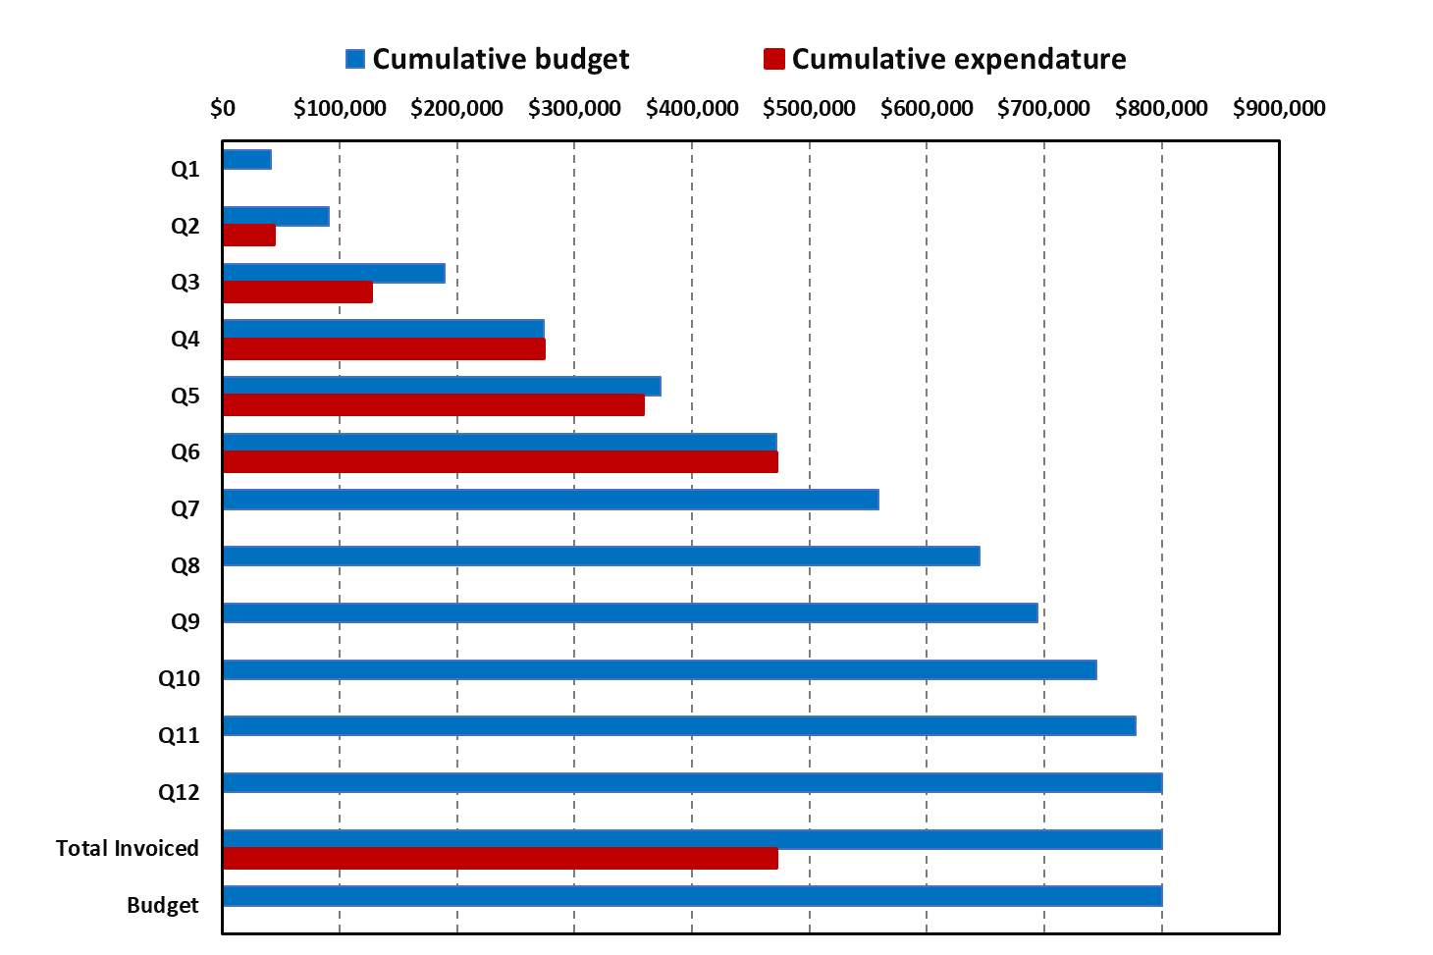

# 4: Project Technical Status

A significant amount of work was conducted during the last quarter, as summarized below.

## Task 1 – Literature Review

Completed.

## Task 2 – Identify Potential Limitations in Components and Pipeline Conditions

This task was completed during the last quarter with the completion of the SME hydrogen elicitation workshop and evaluations done by the SMEs. The following is a short review of those efforts.

In this quarter, work was completed to evaluate the limitations of components and pipeline conditions imposed by pure hydrogen and additions of hydrogen to natural gas. To accomplish this objective, 25 subject matter experts (SME) with a background in pipeline integrity and/or hydrogen effects on steels were identified. In this SME Elicitation effort, we included evaluations of pure hydrogen aspects and blended hydrogen aspects. These individuals came from industry, national laboratories, and academia. Experts from the United States, Europe, and Canada were part of the expert panel. The SME were asked to participate in an elicitation exercise in which questions were posed on various aspects of hydrogen integrity, comparing changes in threats caused by the addition of 5-20%, as well as pure hydrogen. They were also asked to rate their level of knowledge associated with each topic they responded to so that we could characterize the level of confidence in the answers. The elicitation form was developed using an online platform that enabled efficient and anonymous input for the SMEs, as well as post-processing of the results. Seventeen of the twenty-five SME responded to the elicitation questionnaire. On March 20th, we then had an Elicitation Workshop to review the responses and comments. The participants then had an opportunity to update their responses based on the additional information from the discussions. Shown below is a screenshot of the opening page of the online form.

The elicitation process is summarized as follows:

* SME Elicitation questions structured around 16 categories:
  + Material properties,
  + Crack growth,
  + Crack initiation,
  + Effect of fabrication method,
  + Effect of construction,
  + Fatigue demand,
  + Operating pressure,
  + Time-dependent threats,
  + Effect of hydrogen concentration,
  + Stress corrosion cracking,
  + In-line inspection,
  + Threat mitigation,
  + Repair procedures,
  + Flaw assessment, and
  + Non-metallics.
* This elicitation questionnaire was a total of 65 questions.
* Several questions inquired about SME level of confidence (limited <40%; somewhat 40%-70%; high >70%) and rationale for responses.

To illustrate the type of data gathered, Figure 1 is a screenshot showing the response to material properties questions.



Figure 1 Results to Topic 1 on material property changes anticipated from hydrogen gas transportation

The upper-right corner gives pie charts showing the confidence level of the respondents. In addition to the structured questions, the respondents were able to provide some context for their answers, see Table 1. Similar figures and tables were created for the other 15 Topics. A workshop was held at Engineering Mechanics Corporation offices in Columbus the week of March 17th to review the results and permit SME to clarify their answers. The detailed discussion offered opportunities to clarify misunderstood topics and additional information for people to update their responses. Some of the respondents were able to update their input questionnaire following the discussion.

It was also of interest and entertainment that we got some quite opposing opinions, i.e., one participant said, “I know everything, and there are no problems,” while another said, “I know everything, and there are lots of problems.”

Although Task 2 is technically completed with the completion of the elicitation survey to identify “Potential Limitations in Components and Pipeline Conditions,” this is an area where additional information will be developed for years to come. Therefore, Emc2 will provide updates in these quarterly reports as appropriate when new information is obtained, even though it is beyond the scope of the project.

Table 1 Detailed responses to Topic 1 on material property changes anticipated from hydrogen gas transportation

## Task 3 – Evaluate Non-Metallic Components for Retrofit or Replacement

During this reporting period, literature and references compiled earlier involving the effects of hydrogen on non-metallic components in the gas transmission and distribution systems were reviewed in detail. Also, these results were discussed during the DOT elicitation meeting held at Emc2 on March 20, 2024, during the discussion involving non-metallic materials. The Elicitation Panel’s comments on the impact of hydrogen on transmission and distribution pipelines are summarized in Slides 47-49 of the Elicitation Presentation (see below) and may be summarized as follows:

* Most of the panel members had limited or no experience with non-metallics,
* The impact of hydrogen on non-metallics would be dependent on the pressure, though this threshold value of pressure is unknown,
* Hydrogen is expected to have a significant impact on seals and gaskets, and
* The impact of hydrogen on flow meters will need to be considered on a case-by-case basis.

The above feedback is consistent with the literature review findings conducted in this task to date. The complete list of references reviewed is appended below [Ref. 1-24] and a summary is provided below per the various ‘categories’ of past studies:

1. *Impact of hydrogen on gas distribution piping*: Even though it is not clear if the scope of the current project involves the review of hydrogen in gas distribution pipelines or only transmission piping, this literature review included the former as well. A significant number of studies reviewed [1-12] relate to the effect of hydrogen on polyethylene (PE) piping (both medium density and high density, i.e., MDPE and HDPE) - used extensively in gas distribution piping. One study from the Netherlands [12], where PVC is still used for gas distribution, includes the impact of hydrogen on the leak tightness of PVC joint fittings. Most of the technical research on the effect of hydrogen on PE piping in the US is carried out by GTI Energy (formerly Gas Technology Institute) in Des Plaines, IL.

The major conclusions to date from the literature reviewed are that there are no compatibility issues between hydrogen gas and PE and that there are no concerns about the effect of hydrogen on the aging/durability of PE with regard to service life. Other studies involve specific experiments conducted to study the effect of hydrogen on fatigue life as well as on fusion joints, which traditionally have greater susceptibility to slow crack growth, which is similar to creep crack growth in metals and is the most common mode of failure for PE piping in gas distribution service.

1. *Compatibility, diffusion, permeability/leakage, and solubility of hydrogen on non-metallics*: A number of other studies listed in the references [13-17] focus on these issues. To date, the available literature review concludes that while compatibility with almost all polymers and elastomers is not an issue, the major concern with gaseous hydrogen is increased permeability in non-metallics and, hence, leakage, rather than specific threats to integrity. The leakage rate for hydrogen is roughly a factor of 3 greater than that for natural gas.
2. *Effect of high-pressure hydrogen on elastomeric components*: The third major area of study on the impact of hydrogen in non-metallics involves the effect of high pressure (> 2,000 psi) on elastomeric components [18-22]. This is likely motivated by hydrogen fuel cell studies where there is an impact of hydrogen on elastomeric seals and O-rings. Critical properties of elastomers such as compression set, modulus/stiffness, and degree of swell for filled and unfilled polymers used in hydrogen service environments are affected more by pressure-cycling. The primary takeaway from some of the experiments conducted is that material property changes in elastomeric seals at high pressure can cause leaks in industrial systems used to seal hydrogen, which could be a safety concern.
3. *International efforts involving the effect of hydrogen on non-metallics*: Studies conducted outside the US were also reviewed. Specifically, the work the European Industrial Gases Association (EIGA) [13] and European Pipeline Research Group (EPRG) [16] have undertaken since 2004 to study the issues involving the effects of hydrogen on non-metallics is being investigated in detail. These studies address very similar issues as those described above conducted in the US and also identify research needs to be undertaken where gaps exist – including the need for any new test method, studying possible new failure modes, effect of gas decompression, fatigue loading and wear of non-metallics in the presence of hydrogen.

Separately, the Australian Pipeline Gas Association has developed a complete ‘Code’ [23] that consolidates ‘current knowledge’ with a focus on hydrogen fluid compatibility with pipeline materials and components. Specifically, Chapter 11, involving the use of Composite Pipes for hydrogen transport, is being reviewed in detail as part of this effort. Also of general interest is the work by the Pipeline Safety Trust [24], which expresses overall safety concerns with the use of hydrogen in pipelines without any significant data.

*List of References Compiled to date on the Effect of Hydrogen on Non-Metallics*

1. Foulc, Marie-Pierre and others, “*Durability and transport properties of polyethylene pipes for distributing mixtures of hydrogen and natural gas*,” 16th World Hydrogen Energy Conference, Lyon, France, June 2006.
2. Klopffer, Marie-Helene, and others, “*Polymer pipes for distributing mixtures of hydrogen and natural gas: evolution of their transport and mechanical properties after an aging under a hydrogen environment*,” Proceedings of the 18th World Hydrogen Energy Conference, Essen, Germany, May 2010.
3. Kloppfer, Marie-Helene, and others, “*Development of Innovating Materials for Distributing Mixtures of Hydrogen and Natural Gas - Study of the Barrier Properties and Durability of Polymer Pipes*,” Oil & Gas Science and Technology, Vol 70 (2), pp. 305-325, 2015.
4. Project report on “*Hydrogen in the Gas Distribution Networks*,” by the National Hydrogen Strategy for Australia, prepared by GPA Engineering for the Government of South Australian with Future Fuels CRC and COAG Energy Council, 2019.
5. Simmons, L. Kevin, and others “*Gap Analysis on the Impacts of Hydrogen Addition to the North American Natural Gas Infrastructure Polyethylene Pipelines*,” Report Number PNNL-33736 under DOE Contract Number DE-AC05-76RL01830, July 2022.
6. Byrne, Nolene and others, “*Influence of Hydrogen on Vintage Polyethylene Pipes: Slow Crack Growth Performance and Material Properties*,” International Journal of Energy Research

Volume 2023, Article ID 6056999, December 2022.

1. Byrne, Nolene, and others, “*Hydrogen interactions with plastic pipes and elastomeric materials*,” Report No. PRCI-EFS2023-010, Proceedings of the 2023 Emerging Fuels Symposium, Orlando, FL, June 2023.
2. Kim, Mina, and others, “Hydrogenation of High-Density Polyethylene during Decompression of Pressurized Hydrogen at 90 MPa: A Molecular Perspective,” <https://www.mdpi.com/2073-4360/15/13/2880>; Polymers, 15(13), 2880, 2023.
3. Melaina, M. W. and others, “*Blending Hydrogen into Natural Gas Pipeline Networks: A Review of Key Issues*,” Technical Report No. NREL/TP-5600-51995 by National Renewal Energy Laboratory under DOE Contract No. DE-AC36-08GO28308, March 2013.
4. Birkitt, K. and others, “*Materials aspects associated with the addition of up to 20 mol% hydrogen into an existing natural gas distribution network*,” Copyright report by Cadent Gas Limited / Northern Gas Networks Limited, UK, 2019.
5. Raju, Arun S. K., and others, “*Hydrogen Blending Impacts Study*,” The California Public Utilities Commission Final Report Number R13-02-008 under Agreement Number: 19NS1662, July 2022.
6. Hermkens, Rene, and others, “*Leak tightness of PVC fittings with Hydrogen*,” Report No. GT-210280, Project number P000019270, Kiwa Technology, The Netherlands, March 2022.
7. EIGA Report on “*Hydrogen Transportation Pipelines*,” Report No. IGC Doc 121/04/E, Globally Harmonized Document from the European Industrial Gases Association, Brussels, 2004.
8. Kane, M.C., “*Permeability, Solubility, and Interaction of Hydrogen in Polymers- An Assessment of Materials for Hydrogen Transport*,” Report No. WSRC-STI-2008-00009, Rev. 0 by Savannah River National Laboratory, Washington Savannah River Company, 2008.
9. Marchi, San, and others, “*Technical Reference for Hydrogen Compatibility of Materials*,” SANDIA REPORT No. SAND2012-7321 under DOE Contract DE-AC04-94AL85000, Sandia National Laboratories, September 2012.
10. Gallon, Neil and others, “*Hydrogen Pipelines – Design and Material Challenges and Mitigations*,” EPRG Project Number ROSEN UK 14233/EPRG 221/2020 Revision 1, December 2020.
11. Weiland, Nathan, and others, “*Enabling an Accelerated and Affordable Clean Hydrogen Future— Fossil Energy Sector’s Role*,” Final Report on Workshop by National Energy Technology Laboratory, US DOE, September 2021.
12. Menon, Nalini, and Others, “*Behavior of Polymers in High Pressure Environments as Applicable to the Hydrogen Infrastructure*,” Sandia National Laboratories, ASME PVP 2016 Conference, Vancouver, Canada, July 2016.
13. Menon, Nalini and others, “*Compatibility of polymers in hydrogen environments as applicable to hydrogen pipelines and contributing infrastructure*,” Paper Number PRCI-EFS2023-061 at Sandia National Laboratories and Pacific Northwest National Laboratories, Proceedings of the 2023 Emerging Fuels Symposium, Orlando, FL, June 2023.
14. Sang Koo Jeon, and others, “Investigation of Physical and Mechanical Characteristics of Rubber Materials Exposed to High-Pressure Hydrogen”, Published online 2022 May 31; Polymers (Basel). 2022 Jun; 14(11): 2233.
15. EWI Work on effect of hydrogen on elastomers O rings; The Effects of Pressurized Hydrogen on Polymeric Elastomers, Jeff Ellis for polymers ([jellis@ewi.org](mailto:jellis@ewi.org)); <https://ewi.org/the-effects-of-pressurized-hydrogen-on-polymeric-elastomers/>
16. <https://www.pnnl.gov/news-media/hydrogen-compatibility-study-characterizes-performance-rubber-additives>;
17. Wikham, Josh, and others, “*Australia's Hydrogen Pipeline Code of Practice – Research Driven Advancement*,” Paper Number PRCI-EFS2023-005, GPA Engineering, Future Fuels Cooperative Research Centre, Australian Pipeline Gas Association, Proceedings of the 2023 Emerging Fuels Symposium, Orlando, FL, June 2023.
18. Presentation by the Pipeline Safety Trust, “*Safe Energy Transition: Zero Incidents - The Public’s Perspective on Hydrogen Pipeline Safety*,” Proceedings of the 2023 Emerging Fuels Symposium, Orlando, FL, June 2023.

Below are the SME Hydrogen Pipeline Elicitation Workshop results on the topic of non-metallics for transmission and distribution lines, as well as the listing of the participants’ comments.

Figure 2 Summary of elicitation results on the impact of hydrogen on non-metallics for transportation pipelines

Figure 2 Summary of elicitation results on the impact of hydrogen on non-metallics for distribution pipelines

Figure 4 Summary of comments from elicitation participants on the impact of hydrogen on non-metallics for distribution pipelines

## Task 4 – Develop Assessment and Repair Procedures for Identified Anomalies

During the recent project review meeting and the SME elicitation on hydrogen effects on pipelines, there was some discussion on repairs. In the last quarterly report, we showed that the hydrogen concentration can be significant in the fillet weld of a type B repair sleeve when including the weld residual stresses and assuming the pressure could enter the annular gap between the repair sleeve and the pipe.

An overlay repair method that was examined (but not optimized at this time) showed that the fillet weld region could be put into compression in the region where the hydrogen concentration is higher, and there are more likely to be weld flaws present. Industry comments were that it could be possible to use for new repair sleeves, although there could be pipelines with a high number of type B sleeves, which would have to be dealt with.

There is also new industry interest in determining if atomic hydrogen might go through the pipe and in the annular area of a type B sleeve, where it might recombine into molecular hydrogen. The molecular hydrogen would be trapped and might pressurize the annular gap (assuming no through-wall flaws are in the sleeved pipe). The pressurized gap might, in turn, cause the pipe to buckle inwards and be a safety hazard for workers trying to repair such a situation.

In discussion with our industry advisors, they said they have not used a compression sleeve like a PetroSleeve, but that might be a viable approach, just more costly.

Composite wrap sleeves have been used for repairs on existing pipelines with good success. The potential disadvantages or limitations of a composite wrap need to be explored further.

## Task 5 – Assess Critical Flaw Sizes and Respective Detection Thresholds

During the last quarter, the additional efforts by Prof. Gao of the University of Akron were completed – in Task 5.1. A review of this work was presented at the project review meeting on March 21, 2024, at Emc2. Those results are summarized below.

## Subtask 5.1 – Hydrogen Diffusion in Steels under the Influence of Stress and Plastic Deformation and the Resulting Effects on Damage Progression and Fracture Toughness – Development of Fundamental FE Evaluation Methods

## The specific objective of this subtask is to assess long-term integrity for cases that are not possible to assess by simple analysis methods, and need to determine if full-scale testing should be recommended.

## In this effort, we are building on the work by Prof. Xiaosheng Gao of the University of Akron – similar work to that by Prof. Emilio Martínez-Pañeda (University of Oxford, UK), but Gao’s proximity is helpful. Prof. Gao studied at Brown University under Prof. Fong Shih. Emc2 staff worked with Prof. Fong Shih many times in nuclear piping integrity. (Shih developed the GE/EPRI J-estimation procedure.)

Using past publications from Gao, we first started by looking at;

* Hydrogen transport model basic equations
* Double-notched specimen
  + Internal Damage
  + Environmental/hydrogen damage
* Dented pipe
  + No internal pressure
  + With internal pressure
* HELP effect

***Hydrogen transport model basic equations***

Hydrogen is assumed to reside either at normal interstitial lattice sites (NILS) or trapping sites generated by plastic straining by the following equation.



where:

CT: hydrogen concentration per unit volume in trapping sites

CL: hydrogen concentration in NILS

θL: occupancy of the NILS

θT: occupancy of the trapping sites

NL: # of solvent lattice atoms per unit lattice volume

NT: trap density, NT ***(εp)***

Two populations are assumed to be in equilibrium according to Oriani’s theory, and the relationship between θL and θT is:



where:

WB: trap binding energy,

R: universal gas constant, and

Θ: absolute temperature***.***

The diffusion process occurs through transposition between interstitial sites within the lattice. Elastic lattice expansion from the hydrostatic stress increases the solubility for atomic hydrogen, whereas inhomogeneities from dislocations act as traps. The governing equation for transient hydrogen diffusion is:

where:

DL: hydrogen diffusion coefficient through NILS,

VH: partial molar volume of hydrogen, and

σh: hydrostatic stress.

Hydrogen-induced lattice deformation needs to be included, which is purely dilatational, elastic, plastic, and lattice straining from hydrogen.

The equivalent plastic strain is calculated as follows:

***Illustration of effects with offset double-edge notched tension specimen***

Material properties are taken from Taha and Sofronis (2001) in Table 1, and the FE model is shown in Figure 2.

Figure 3 Offset double-edge notch specimen used to illustrate the different hydrogen concentration contributions

Other inputs to the analyses were:

* The trap density for iron and steel is given as a function of local effective plastic strain A black background with a black square

  Description automatically generated with medium confidence
* Used two sets of diffusion coefficients and hydrogen
  + DL = 0.0127 mm2/s and 2.084x1012 atoms/mm3 (from literature), and
  + DL = 3,600 mm2/s and C0 = 2.5 ppm (corresponding to 1.18x1016 atoms/mm3) for sensitivity study
* DEN(T) specimen has high shear stress and localized triaxiality
* Initial surface hydrogen concentration (uniform CL0): 2.084x1012 atoms/mm3
* Diffusion coefficient (DL): 0.0127 mm2/s
* Outer edges of the specimen: insulated
* Loading: 0.2-mm displacement on the top edge is applied in 106 seconds (quasi-static, steady state condition reached)

Illustration of effects with offset double-edge-notched tension specimen shows the total hydrogen concentration on the surface and at the center of the specimen; see Figure 3.

Figure 4 Total hydrogen distribution (Ctotal = CT + CL) for this case

To understand the total concentration effect, the CL contribution is a function of the hydrostatic stress (3sh), while the CT contribution comes from the plastic strain (ep). These calculated parameters are illustrated in Figure 4 for the surface of the specimen and in Figure 5 at the mid-thickness. This evaluation shows different concentration components (CL and CT) vary in shape and location from hydrostatic-stress and plastic-strain distributions. The CT concentration was the dominant component of the total hydrogen concentration for this example analysis.

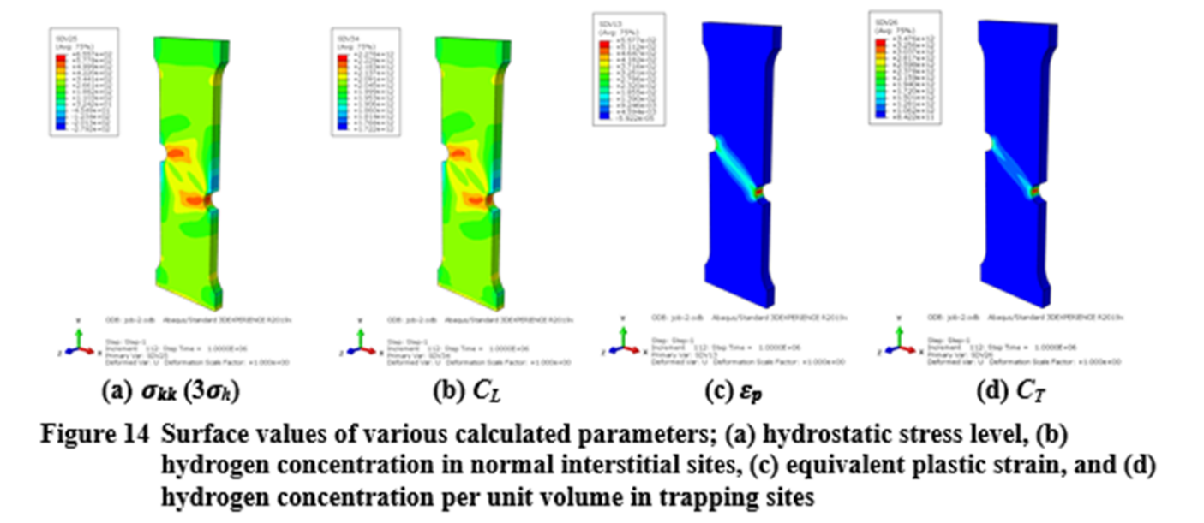

Figure 5 Surface values of the various calculated parameters

Figure 6 Mid-thickness values of the various calculated parameters

***Incorporating HELP Effect***

Hydrogen in solid solution decreases barriers to dislocation motion, which increases the plastic deformation in a localized region adjacent to the fracture surface or high-stressed regions. Sofronis et al. proposed a simple model to describe this behavior, termed the HELP effect, which reduces the very local yield stress with the increase of hydrogen concentration. The equations for this are:

Where**:**

c = hydrogen concentration,

σo = yield stress with no presence of hydrogen,

ξ = softening parameter defining the yield stress when the hydrogen concentration equals co and

η = lowest possible value of yield stress (minimum yield strength) from the hydrogen.

Calculations were undertaken to explore the significance of the HELP effect for the same offset double-edge-notched specimen. 𝜉 and 𝜂 were taken as 0.95 and 0.85, respectively. The results of the hydrogen concentration contributions and the total hydrogen concentrations on the surface are shown in Figure 6. With the HELP effect, more trapping sites are available, so the CT hydrogen concentration is further increased, although the peak values only go from 5.69e+12 atoms/mm3 to 6.17e+12 atoms/mm3.

A blue rectangular object with a blue rectangular object with a blue rectangular object with a blue rectangular object with a blue rectangular object with a blue rectangular object with a blue rectangular object with a blue rectangular object

Figure 7 Double-edge-notched tension specimen results using the HELP effect to reassess the hydrogen concentration

The value of this exercise was to show that the hydrogen concentration can come from two different contributions, where in other cases, the ratio of the concentrations may change from CL controlling rather than CT.

***Dented Pipe Evaluations – with Internal Pressure***

This example case was to explore the relative peak hydrogen concentration to the ID surface exposed hydrogen concentration. This local/applied hydrogen concentration ratio is helpful in judging what type of integrity challenge might be more worthwhile in future full-scale evaluations for the 5-year plan being established in our companion DOT/PHMSA hydrogen pipeline project.

For the dented pipe evaluation conducted, this was done with a simple 2D dent configuration as illustrated in Figure 7. The problem conditions were the following:

* 36-inch (914.4 mm) outside diameter and 0.39-inch (9.9 mm) wall thickness X52, typical of a vintage linepipe
* The head of the indenter has a radius of 2 inches (50 mm)
* Internal pressure of 5.592 MPa (811 psig), then indent the pipe
* Indent the pipe 120 mm, then release the indenter
* Initial hydrogen concentration at ID of Co = 2.084x1012 atoms/mm3, and diffusion coefficient (DL) of 0.0127 mm2/s
* Repeated with hydrogen concentration at the ID of Co = 1.18x1016 atoms/mm3 (2.5 ppm) and diffusion coefficient (DL) of 3600 mm2/s.
  + This second case was used in some initial Emc2 hydrogen concentration sensitivity studies with limiting ABAQUS functions for only one hydrogen concentration contribution. The ABAQUS built-in model does not account for the trapping sites generated by plastic deformation (the CT contribution) that can be important for dented pipes, welds, wrinkle bends, etc.

For the results illustrated in Figure 7, the atomic hydrogen concentration is dominated by the CT contribution when using the lower Co and DL values. With the higher Co and DL values, the atomic hydrogen concentration is dominated by the CL contribution.

The implications of these trends may be important for initially having low H2 blends (i.e., less than 5%) that eventually increase to more than 20% or greater.

During the discussion of our technical industry advisory panel, they suggested that the dent profile might also be very important, i.e., if there was a sharper-edged rock the pipe was resting on. Depending on our budget restrictions, that may be explored, but it is certainly an aspect for future project evaluations.

Figure 8 Comparison of the total atomic hydrogen concentration in the dented pipe after denting then introducing the hydrogen with pressure and sufficient time for steady-state conditions to develop

***An Evaluation of Hydrogen Concentration in an External Local Thinned Area***

This evaluation was of a typical corrosion patch, where the laser scanning of the corrosion 3D geometry was implemented into an FE model. The initial FE model was developed in a prior DOT/PHMSA SBIR project at Emc2 and is shown in Figure 8. The other aspects of this FE model were:

* 36-inch diameter, 0.625-inch wall thickness X52 steel pipe,
* 3D shape of corrosion from laser scan to make 3D FE model – greatest depth = 43.6% of wall thickness, length = ~7 inches, and width = ~4 inches,
* Simulated with and without prior hydrotest at 1.25 x MAOP (1,795 psig), and operating pressure of 72% SMYS being 1,436 psig,
* H2 Co on ID surface set to 2.084x1012 atoms/mm3 (2.5 ppm H2) on ID and zero on OD.

The hydrostatic stresses and plastic strains at the deepest location were across Section A-A, see Figure 9.

The calculated CL and CT in the FE model are shown graphically for the cases with and without the prior hydrotest, see Figure 10. The results suggest that there is only a minor increase in CTotal with a prior hydrotest. More importantly, the relative hydrogen concentration at the flaw region to that on the ID surface is not as high as other flaw types. Hence, such corrosion flaw testing may be a low priority for recommended future full-scale testing.

Figure 9 Detailed FE model of a corrosion patch geometry taken from field laser scanning measurements

Figure 10 FE calculated hoop stresses on the OD surface (Section A-A is the critical location)

Figure 11 Calculated hydrogen concentrations in the corrosion patch FE model

***Hydrogen at an Axial Flaw Away from a Weldment***

The objective of this evaluation was to see the effects of a hydrotest prior to hydrogen service on the hydrogen concentration at a surviving surface crack. Several different hydrotest levels were examined, but the one shown here is 1.50-times MAOP rather than the current 1.25-times MAOP. Some additional details are:

* 16-inch diameter, 0.267-inch wall thickness X52 steel pipe was modeled,
* a/t = 0.4, 4-inch long, canoe-shaped axial OD crack; ¼-symmetry
* Three levels of MAOP (50%, 60%, and 72% SMYS)
* Two levels of hydrostatic testing (1.25x and 1.5x MAOP) were used
* Co = 2.084x1012 atoms/mm3 (2.5 ppm H2) on the ID and zero on the OD.

The numerical results were that the peak hydrogen concentration was dominated by CT (from ep). When the hydrotest increased from 1.25 to 1.5, the peak hydrogen was not changed, but the whole region was affected by the hydrogen increase. The highest value is in the center of the crack, so there is more toughness reduction there.

Figure 11 shows the numerical calculations of the hydrogen concentrations at the three different MAOP stress levels. There are a few interesting observations in this figure. First, at the high MAOP of 72% SMYS, there is a much greater hydrogen concentration off the crack tip than in the other lower-stress cases. So, for this situation, if the toughness varied greatly with the local hydrogen concentration, the failure pressure might be less affected at the lower stress levels. (Of course, if those cracks were larger and closer to their critical crack size, the hydrogen concentrations would increase.) Secondly, note that the hydrogen concentration follows the shear bands emanating from the crack tip. So, the local hydrogen concentration needs to account for it not being straight ahead of the crack tip through the ligament. Finally, the green color is the applied hydrogen concentration on the ID surface. The local hydrogen concentration is much larger near the crack tip region than on the ID surface, making this a much more severe case than the corrosion patch case.

**Figure 12 FE calculations of hydrogen concentration of same size surface crack at different MAOP stress levels (after 1.5*MAOP hydrotest)**

***General Commentary on the FE Hydrogen Concentration Analyses and Fracture Mechanics Constraint Interactions***

From the above cases, and many more not presented here, the relative hydrogen at the crack/flaw region to that applied on the ID surface is a general indication of the ranking of the importance of hydrogen to that type of integrity challenge. What is not known now is how to relate the ***local*** hydrogen concentration to toughness degradation. That is the next challenge to undertake.

To undertake this relationship of JHIc versus local hydrogen concentration, we thought a good starting point would be to take autoclave hydrogen testing data on, ideally, a vintage linepipe steel where tests were done with different partial pressures using C(T) specimens. When looking at autoclave testing data from several sources, we found that the standard C(T) size was not used. The standard size C(T) specimen[1] is used in an inert environment to correlate to the toughness for a surface crack in a pipe. Figure 12 shows how the standard C(T) specimen relates to the toughness for SEN(T) specimens that agree with surface-cracked pipe tests in an inert environment. C(T) specimens are “high-constraint specimens” (in fracture mechanics terminology) giving a lower toughness than a tension specimen. For single-edge-notched tension, SEN(T), specimens that have good similitude to a surface crack in a pipe, the initiation toughness increases as the depth/thickness of the crack decreases.

This empirical relationship only holds for the preferred C(T) specimen per ASTM E1820. Additionally, the thickness of the C(T) specimen is equal to the width of the SEN(T) specimen. The SEN(T) specimen with a crack oriented in the same direction as a surface crack has a thickness equal to the pipe thickness. This relationship works well for *all materials* on the upper-shelf toughness temperature region. Due to the constraint similitude with a surface crack, the SEN(T) specimen also determines the brittle-to-ductile transition temperature of the surface-cracked pipe, whereas a C(T) test will give a much warmer brittle-to-ductile transition temperature.

Ideally, autoclave hydrogen testing would be done with fixed-grip SEN(T) specimens for more direct similitude with surface-cracked pipe, but C(T) specimen testing is much easier. In looking at the autoclave hydrogen test data, the W/B values of the C(T) specimens were greater than 2 and, in one case, up to a ratio of 7, meaning the thickness was ~28 percent of the standard ASTM specimen. Other cases are variable from pipe material to pipe material depending on the original thickness of the pipe. Some are closer to W/B=2 on occasion so that no single correction could be used. For example, this factor of 28% of a standard specimen is estimated from Figure 13 to give a toughness value of 2.5 times higher than the standard C(T) specimen in an inert environment. The complication with the hydrogen is that a higher toughness value comes from the higher amount of plastic strain. As illustrated in Figure 11, the higher plastic strain will draw more hydrogen to the crack tip (the CT contribution increases), which may decrease the toughness further (relative to an inert environment) than from standard C(T) testing.

Compounding some of the autoclave testing is that some C(T) tests are first used from fatigue crack growth rate testing. From looking at fracture surfaces in published papers, it seems that the a/W of the C(T) test could be about 0.7. C(T) specimen (like SENT and SENB) Ji values are also sensitive to different a/W values. The a/W value of 0.7 in the C(T) test will reduce the toughness (in an inert environment).

A final aspect that needs understanding is the effect of hydrogen on surface cracks of different a/t values in pipes. Figure 14 shows the FE results of three different SEN(T) specimens at load levels where the start of ductile tearing occurred. The plastic strain fields are shown. It can be clearly seen that the shallower crack (with higher toughness) had a large plastic strain – which makes sense. However, that larger plastic strain field should cause a higher hydrogen concentration. If the magnitude of the change in the hydrogen concentrations is important to the fracture resistance, then one might expect the shallower crack fracture behavior to be more affected by hydrogen than the deeper cracks. The results might be a flattening of the Ji value as a function of a/t [as shown in Figure 12(a)].

An important conclusion from these assessments is that for the hydrogen degradation evaluation, the effects of constraint on specimen geometry and, more importantly, on surface-crack geometries in pipes have not received any attention up to now.

1. Initiation toughness values (b) J-R curves in SEN(T) specimens

Figure 13 Correlation between standard C(T) specimen Ji values and Ji values from SEN(T) specimens with different a/W values, and change in J-R curve from SEN(T) specimens with different initial a/W values

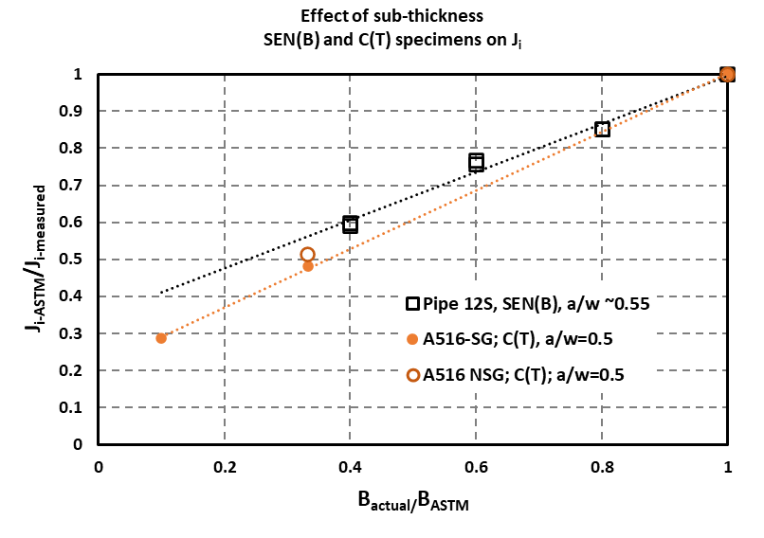

Figure 14 Correlation between Ji values from standard ASTM C(T) and SEN(B) specimen geometries with subthickness specimens – keeping a/W ~0.5

Figure 15 FE results showing the plastic strain fields at the crack tip of the SENT specimen at the load level corresponding to the crack initiation for the different a/W specimen geometries

## Subtask 5.2 – Near-Term Critical-Flaw-Size Evaluations

The efforts in Subtask 5.1 are fundamental longer-range developments that have great value. However, there are some pragmatic cases where engineers might try using existing methods and just input a toughness from autoclave hydrogen testing, without consideration of the interactions of constraint and hydrogen degradation that are pointed out above. Below are a few example cases that are thought to be of high pragmatic interest.

***Hard Spot Critical Crack Size Evaluations for Burst Pressure – Simple Axial Cracked Pipe Evaluation***

Hard spots exist in vintage pipelines typically made before the 1970s. They have been responsible for service failures in the past and some more recently. Existing pipelines' hard spot failures typically happen from exposure to wet soils, degraded external coatings, and cathodic protection current. This combination is known to create a high density of hydrogen on the surface, which can cause Hydrogen Stress Cracking (HSC). For a pipeline transporting hydrogen, the atomic hydrogen concentration may be less than CP-induced hydrogen, but the hard spots need not be exposed to wet soils or have external coating damage. So, it is desired to know the relative behavior of hardspots for hydrogen gas transportation versus current service experience with externally generated hydrogen.

The first evaluation conducted here was to determine the critical flaw size in hardspots with different hardness values. The variables were:

* 36” by 0.44” X52 pipe (but looked at 24” and 30” too – similar trends)
* Predicting critical surface crack sizes at 72% SMYS
* Other inputs:
  + Stress-strain curve, flow stress, or yield strength – assumed no H2 effects
  + Base metal properties typical from our testing
  + Hard spot strength varied with BHN – used BHN of 350, 400, 460 (350 is about lower level of service failures). Yield and ultimate values from NG-18 reports #37 and #151. Estimated stress-strain curves knowing % elongation.
  + Fracture toughness inputs depend on the analysis used and were; Charpy upper-shelf energy, C(T) specimen Ji, or SEN(T) specimen Ji
  + Base metal calculations done as a reference case, no hydrogen effects on the base metal in these calculations. All the material property data for the base metal is well known.
  + Used C(T) Ji of BHN=350 with and without hydrogen from Report #151. From those values we could estimate CVP, SENT Ji’s values. Interestingly, this BHN=350 material had ductile tearing, not cleavage fracture.
  + For BHN of 400 – extrapolated trends based on Sy and Su – assumes ductile tearing since that was the failure mode of the base metal and BHN=350 data used in the extrapolation process. It is possible that cleavage failure might occur for hardness values greater than 350 BHN. Need toughness data on hard-spot material in the future.
  + For BHN of 460 – extrapolated trends based on Sy and Su – assumes ductile tearing since that was the failure mode of the base metal and BHN=350 data used in the extrapolation process. It is possible that cleavage failure might occur for hardness values greater than 350 BHN. Need toughness data on hard-spot material in the future.

## The stress-strain curves for the hardspot materials are probably the most reliable and are shown in Figure 15. The toughness values are used only for this sensitivity study and, due to the extrapolation needed due to lack of data, should not be used elsewhere, see Table 2.

Three different burst-pressure models were used. These models include only the pressure for the crack driving force and assume the pipe is perfectly circular. Hard spots will also have a flat region in the pipe. The crack-driving force for the real situation would also contain the bending stress from the flat region, the plate-to-pipe forming stress since the pipes back then were not stress-relieved or mechanically expanded, and residual stresses from the phase transformation and thermal-plastic stress during the creation of the hard spot.

The burst pressure analyses were:

1. The original Ln-Sec equation used the flow stress for strength and Charpy plateau energy for the toughness input,
2. The CorLAS equation used the yield and strain-hardening exponent from the stress-strain curve for strength and C(T) specimen Ji value for toughness, and
3. The Emc2 FE-based J-estimation scheme that used the stress-strain curve’s Ramberg-Osgood parameters for strength, and the Ji toughness as a function of a/t.

Figure 16 Stress-strain curves used for the input to the simple hard-spot burst test analyses

Table 2 Material toughness inputs used for the different simple burst test analyses



The results of these analyses are shown in Figure 16. In summary, the results showed:

* The Original LnSec shows critical crack keeps decreasing with length, which has been a problem with this method in the past (the reason the Modified LnSec equation was developed, but it doesn’t work for low CVP values).
* Emc2 FE-based J-estimation procedure shows the crack length reaches a saturation level with a/t, which is also consistent with trends with MAT-8 analyses for other analyses.
* CorLAS has a similar trend as the Emc2 method for the base metal and BHN=350 but could not solve for higher hardnesses. There is a basic equation problem for higher-strength steels that results in negative failure pressure.

Typical hard spot length is 9” or c/T of 20.5 for this pipe size, the region of interest.

So interestingly, the results using even these simple methods are more varied than expected.

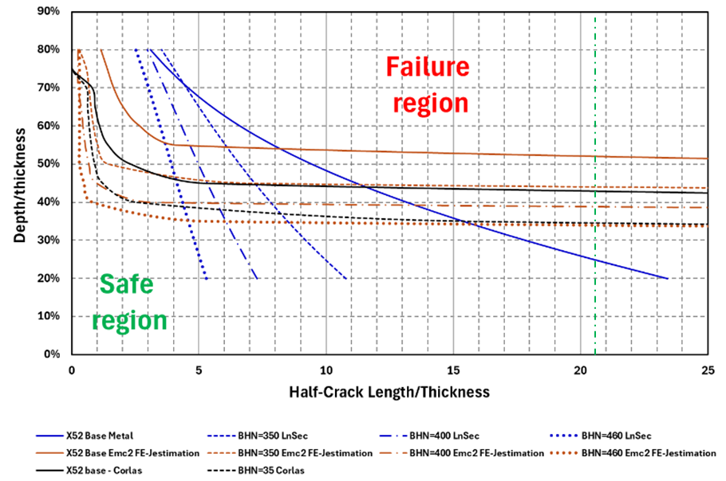

Figure 17 Burst pressure results for axial surface cracks in hard spots using simple analysis methods

***Hard-Spot Critical Crack Evaluations – FE Results to Date***

Because the simple axial crack burst pressure models, do not include all the crack driving force contributions and/or may not be validated for much higher strength material like the hard spot material, a more fundamental FE analysis has been started.

In looking at hard spot data, it can also be seen that the hardness is variable. It is the highest in the center and then decays to the hardness of the base metal, see Figure 17. It can also vary through the thickness. The variability from the highest hardness value in the center towards the edges could be handled in the FE model with a strength gradient, although that was not done at this time. (Interestingly, the hardness gradient also means that the crack tip from an HSC might not be located in the highest hardness region since the crack already grew in that region.) For this initial evaluation, the hardness was kept to constant values throughout the entire hard spot region and through the thickness. Those hardness gradient refinements could be added later.

The FE model created had the following attributes and inputs;

* The 3D pipe FE model had ¼ symmetry
* The same 36” by 0.440” X52 pipe as in simple estimation analyses was used
* Hard-spot region taken as 6” – a little smaller than average (~9”)
* Hardness was only BHN=350 in the hardspot FE region, and the base metal strength elsewhere, and used the stress-strain curve shown previously
* OD axial surface cracks centered in hard spot (total lengths of 2”, 4” and 6”)
  + Service history shows they can be the entire length of a hard spot
* The crack was pinned closed for uncracked stress evaluation
  + Through thickness bending of ~20 ksi occurred in the center of the hard spot – compression on ID in the uncracked FE model. This is an additional crack driving force that is not in the simple axial crack burst pressure models.

The 12 different FE models had the following crack lengths and depths matrix. The crack geometry was a constant depth with quarter-circles at the ends.

* a/t = 0.2, 0.4, 0.6, 0.8, and
* 2c = 2”, 4”, 6”

The J values were at the center of the crack and shown versus pressure, see Figure 18.

* The shape of J versus pressure curve for deeper, longer cracks affected by through-thickness bending.
* Toughness levels for BHN material with estimated H2 degradation at different a/t values (from Table 2) are horizontal lines in Figure 18.

The critical crack geometries can be determined by comparing the ratio of the applied J values at pressure for 72% SMYS to the Ji values for the appropriate a/t case versus the crack lengths in Figure 19. The results were that;

* The critical length for a/t=0.8 was 2c=2.2”,
* The critical length for a/t=0.6 was 2c=4.3”,
* The critical length for a/t=0.4 did not exist, i.e., a/t was too small even for very long lengths,
* The critical length for a/t=0.2 did not exist, i.e., a/t was too small even for very long lengths, and
* The critical crack lengths for a/t=0.7 and 0.5 were interpolated.

Figure 20 compares the critical surface-crack sizes from these initial FE analyses to those from the simple burst pressure analyses. The following observations can be made.

* The FE curve is closer to the shape of CorLAS and Emc2 axial surface crack solutions for longer cracks. The Emc2 method was the closest.
* For short cracks, the FE model was closer to LnSec results.
* Easy to use non-hydrogen BHN=350 toughness values too (Rpt#151) – not done.
* Since all setup, could repeat with BHN=400 (recall, no solution by CorLAS)
* Could have hardness transition from the center to the perimeter as well in the future.

None of these models includes the thermal-plastic/phase transformation residual stresses yet or the plate-to-pipe fabrication stresses, which may make the critical crack sizes smaller in the FE model results. Once all these stress contributions are properly in the FE model, then the FE H+ concentration modeling can predict the (Ctotal) with gaseous ID hydrogen versus external CP hydrogen.

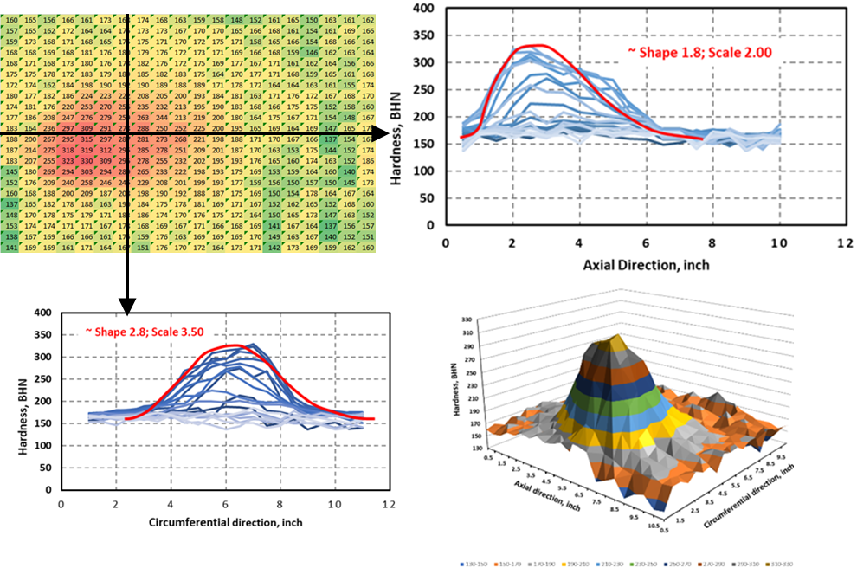

Figure 18 Mapping of harness values in a hard spot found in service

Figure 19 FE results of pressure versus the Japplied at the center of the surface crack that is centered in the 350BHN hard spot

Figure 20 Ratio of the Japplied at 72% SMYS to Ji of the surface flaw versus crack length to determine the critical crack sizes

Figure 21 Comparison of initial FE critical crack sizes to the simple pipe burst test model for BHN=350 with hydrogen degraded toughness and pressure of 72% SMYS in the 36” by 0.440” X52 pipe

***ERW Seam Weld Evaluations***

Another very pragmatic concern for repurposing vintage pipeline is the sensitivity of ERW seam weld flaws to hydrogen degradation. To our knowledge, other than a few tests done in the early 1980s (NG-18 report 151), there are no ongoing experimental values to assess ERW seam weld toughness sensitivity.

From the efforts in Subtask 5.1 on hydrogen concentration modeling, it is well shown that the trapping contribution to the hydrogen concentration (CT) is controlling for axial flaws (in base metal, see Figure 11), which comes from the plastic strain.

All the existing burst pressure models for oil/gas applications assume the base metal strength is everywhere (including the flaw ligament) and use the toughness of the welds. That is a frequent practice. In some nuclear piping applications for cracks in welds, the weld metal strength is included in the J-estimation scheme.

For some lower-toughness ERW/EFW seam welds, the weld hardness can be much greater than the base metal. To explore this aspect deeper than has been done in other oil/gas pipeline work, FE analyses were conducted that included the strength of the weld metal and the axial surface crack centered in the weld. From looking at hardness maps of ERW/EFW weld regions, it was concluded that the weld region is reasonably modeled as a rectangular cross-section, see Figure 20. The Emc2 FE mesh generator was used to create FE meshes with and without weld regions. The following are the variables used.

* 16” diameter by 0.246” X46 pipe (actual strength comparable to X52),
* a/t = 0.4, 0.6, and 0.8, and
* t/c = 0.5, 0.0625, and 0.001 (2c = 1”, 8.6” and 53”).

A typical base metal stress-strain curve was used, while the weld was assumed to have a BHN=350 hardness (Hv=361), d-c ERW Hv values of up to 536 have been reported in the past, so this is on the more common lower side.



Figure 22 ¼-symmetry FE model showing a short axial surface crack in an ERW weld

Comparison of the all base-metal and base plus weld FE calculated Japplied values versus pressure are shown first for the shorter crack lengths of t/c=0.5 (total axial lengths of 1.0”). Curves for a/t of 0.4, 0.6, and 0.8 are shown in Figure 22. These crack lengths are so short there is essentially elastic behavior in all cases.

For the intermediate crack length of 8.6”, the results are shown in Figure 23 for the three crack depths. In these cases, the differences between the weld plus base metal results and the all-base-metal results are becoming significant. For instance, at a pressure of 72% SMYS (~1,100 psig) for the a/t=0.6 surface crack, the difference in the Japplied values is a factor of over 2.

For the longest crack length of 53” (hook crack can be that long), the results are shown in Figure 23 for the three crack depths. More than likely, the same results would be obtained with shorter crack lengths than this since the critical length of the crack becomes constant after some length (like in Figure 20). In these cases, the differences between the weld plus base metal results and the all-base-metal results are significant for the shallower surface cracks. For instance, at a Ji toughness level of 50 in-lb/in2 (typical of these types of welds), the FE model with the weld predicts a failure pressure of 1,200 psig, while the all-base-metal FE model predicts a failure pressure of about 600 psig. Another way of looking at these results is that if there were a failure at 1,100 psig, the analyses with all-base-metal strength (typical of all burst pressure procedures) would predict that the toughness would be 5 times greater than it really is. So, one needs to be careful in backing out a toughness from service failure when using simple burst pressure models.

From the past nuclear piping procedures we have developed for cracks in welds, it was possible to modify the J-estimation analyses by determining an effective yield strength and strain-hardening exponent from FE results, somewhat similar to a rule of mixtures, but guided by the FE calculations.

With these FE models, it is also possible to calculate the difference in the hydrogen concentration at the cracks per the analyses shown in Subtask 5.1.

Figure 23 Comparison of FE results with and without weld metal strength included for the shortest crack length of 1.0” and three a/t values



Figure 24 Comparison of FE results with and without weld metal for the intermediate crack length of 8.6” and three a/t values

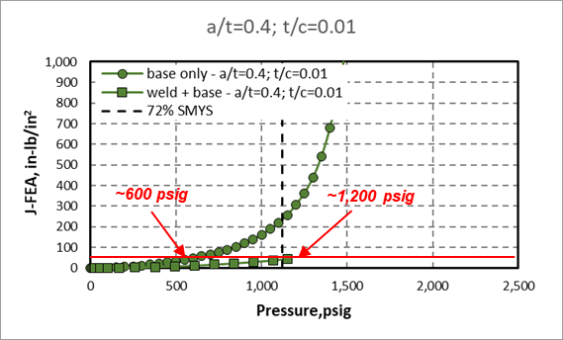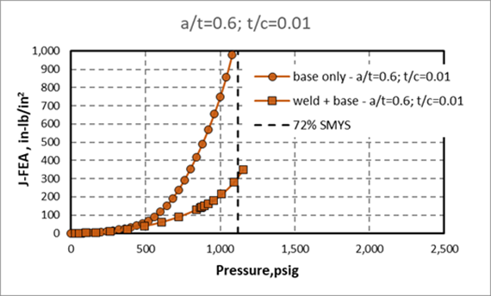

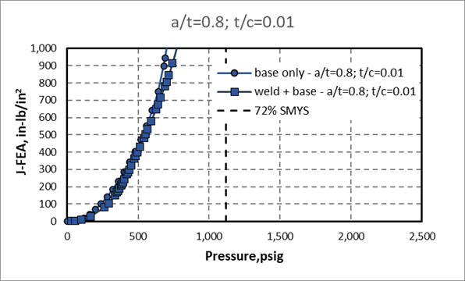

Figure 25 Comparison of FE results with and without weld metal for the longest crack length of 53” and three a/t values

## Task 6 – Review Regulatory Requirements for Safety Implications of Pipeline Conversion

There is active research in all regions of the world looking at the effect of hydrogen addition on pipelines now transporting natural gas. These efforts are developing data that can be used to develop codes and standards as well as inform regulatory bodies. As part of Task 6, data is being gathered on the status of rulemaking and limitations that have been imposed on hydrogen blending. It is well established that hydrogen has an adverse effect on material properties, and hydrogen-natural gas blends will behave differently during a failure event. This study is focused solely on the effects of hydrogen on the integrity of transmission pipelines; however, studies such as the Sandia work on the release behavior of blended gases have shed light on the consequence aspects of a release[2]. Beyond the direct effects of hydrogen on the properties of steel pipelines, the thermodynamic properties of hydrogen may affect operations conditions that impact integrity. As the hydrogen content is increased, there is a reduction in the calorific value of the gas mixture. As a result, there may be the need for higher flow rates, a change in system pressure, or additional parallel pipelines.

Currently, limited commercial pipelines within the United States transport a blend of hydrogen and natural gas. The most widely referenced is Hawaii Gas, which has operated a blended hydrogen pipeline for decades at a maximum of 12% mixture. This line operates under current federal regulation 49 CFR Part 92. This regulation addresses hydrogen in only an indirect manner and does not provide specific limitations. A graphic depicting the current regulatory framework is shown in the figure below, reproduced from a Sandia National Laboratory presentation by Ehrhart et al.[3]

Figure 26 Graphical depiction of the current US Federal Regulatory framework for hydrogen transportation

As laboratory studies continue, some demonstration projects are underway, looking at various aspects of hydrogen transmission as well as storage, distribution, and end-use. A recent study conducted for the California Public Utilities Commission by the Gas Research Institute (GTI) in 2022 identified four additional hydrogen blending projects involving transmission pipelines, and more are currently being planned[4]. A project conducted for the Emerging Fuels Institute of Pipeline Research Council International (PRCI) by GHD Inc. in 2020 listed current blending limits on hydrogen blending around the world[5]. They range from 10% volume (Germany Decree no. 2004-555) to as low as 0.1%vol in the UK (HSE Gas Safety Management Regulations 1996). Another recent study by NREL published the following table of hydrogen blending limits:

Table 3 Regulatory limits on hydrogen blending by country, given as % volume. Note the absence of information from this table does not imply that blending is unrestricted. Data compiled from various sources, including the European Hydrogen Law Database (HyLaw), a survey of European regulators by the Agency for the Cooperation of Energy Regulators (ACER), academic papers, and other sources

It can be concluded that regulatory efforts in most countries to address the effects of hydrogen are still in the early stages owing to the state of knowledge and lack of test data and models capable of predicting the integrity limits of pipelines containing hydrogen. However, based on the many studies and the pace of development, it is likely that sufficient information will be available in the next few years to address the safety of hydrogen blending into existing natural gas pipelines.

The deliverable for this project will distill all the available literature on the effects of hydrogen pipelines on integrity and outline the areas that should be addressed. However, given the state of knowledge, only general guidance is possible with respect to specific limits of hydrogen or permissible maximum pressures or fatigue demand. Similarly, limits on the criticality/acceptance of defects, such as cracks, dents, gouges, etc., can only be provided in relative terms to current limits for natural gas service. To provide this, both experimental data taken from literature and state-of-the-art modeling work performed by Emc2 will be used to evaluate the change in criticality of various types of defects in hydrogen. These techniques, primarily involving phase-field analysis, are phenomenological in nature and are used to describe various mechanistic descriptions of hydrogen embrittlement on fracture toughness and tensile ductility. This provides insight into the potential magnitude of the effect of hydrogen on the integrity of different forms of damage. Based on this, it will be possible to provide some guidance on the more critical areas on which future regulations should focus.

## Task 7 – Determine and Describe Necessary Operator Actions

The focus of Task 7 is the development of operator actions required to maintain integrity levels at the current level following the introduction of hydrogen. This work is focused on the following key areas representing failure mitigation steps:

1. In-line inspection (ILI) will play a key role in monitoring and sizing defects. The effects of hydrogen are known to reduce crack tolerance, increase fatigue crack growth rate, and decrease tensile ductility. Therefore, the tool selection, as well as the frequency of inspection, will be an important factor in integrity management plans. In particular, crack detection and sizing of current ILI tools are being evaluated and compared to tolerable flaw size as a function of operating pressure and hydrogen concentration. Also, the crack growth rate under a range of pressure cycling conditions is being evaluated to help develop guidance for tool run frequency. Given the smaller tolerable crack size and increased crack growth rate, it is expected that ILI frequency would need to be increased compared with current inspection plans. Baseline ILI inspections are desirable prior to the insertion of hydrogen blended gas. As pointed out in our SME Elicitation hydrogen workshop, the electromagnetic properties of steel may change with hydrogen. So, it may be necessary to determine if these changes in the steel properties affect the ILI inspection readings.
2. As an alternative/supplement to ILI, pressure testing is expected to play an important role in establishing maximum flaw size in a similar fashion to today. However, the potential for stable crack growth under constant load, the so-called KIH limit, will require some attention. The guidance for pressure testing will include information regarding this consideration.
3. As hydrogen also affects the tensile fracture strain, it is expected that limits on various forms of deformation may be impacted. This is being studied as part of the hydrogen concentration and phase-field modeling effort. The fracture strain changes might affect integrity challenges such as corrosion patches, dents, gouges, wrinkle bends, buckles, etc. While no full scale-test data is available to validate/calibrate this study at this time (or by the time this project ends), it will provide some valuable information in comparing the criticality of defects such as dents or gouges in hydrogen compared with natural gas. As a result, it is expected that the detection and sizing of locations of high-strain concentration will require greater attention, likely through the use of ILI tools.
4. Welded repair/alteration of defects is another area that will be important to operators. As hydrogen will migrate to locations of high tensile strain, consideration of welding procedures or the use of non-welded repairs may be needed. This is also being evaluated using the phase field modeling techniques to examine hydrogen concentration in weld configurations such as a fillet on a Type B sleeve. In other industry work done with high-temperature hydrogen-assisted cracking, the stop-start locations of the weld provided higher local residual stresses, which might also attract more hydrogen for transmission line applications.

# 5: Project Schedule

The below project GANTT chart was updated from the prior quarterly report. We have caught up on the efforts that were slightly behind in the last quarter.



1. ASTM E1820 fracture toughness test standards has preferred C(T) specimen geometries that are W/B=2 and a/W=0.5; where W=width of the specimen, B=thickness, and a=crack length.
2. Sandia Report SAND2021-9802, 2021.
3. Overview of Federal Regulations for Hydrogen Technologies in the U.S., April 29, 2021, SAND2021 5070 PE
4. Hydrogen Blending Impact Study, Prepared by University California Riverside for GTI, 2022.
5. PRCI Report PR-720-2003-R01